Internal Errors Displays Externally

Priority: High (this is a security risk, but doesn’t stop operations)

Customer Impact: Low

When an error happens on the webserver, the full server error message is displayed to the public. This is a security concern because this information can be used to build up a profile of the tool and practices we use.

There are currently two ways to reproduce this, see bugs 5 and 6. Bug 6’s reproduction steps are presented below.

Steps to reproduce:

1. Navigate to the [Home](https://ensekautomationcandidatetest.azurewebsites.net/) page
2. Click Login on the title navigation bar
3. Enter a valid email address or [brookrichardson@protonmail.com](mailto:brookrichardson@protonmail.com) in to the Email field
4. Enter 9kZM4InUpomrHT& into the Password field
5. Click the Log in button

The customer should see a user friendly error message, but instead they see the full internal error log. This is an issue because it allows attackers to build up a profile of our tools and should be resolved as swiftly as possible.

For a customer, displaying an “Error 500” would be much better, or simply telling them that we are experiencing issues and that they should come back later.

Assuming we are using a .Net server the app.UserExceptionHandler should be set to “/Error” and the event should be logged.

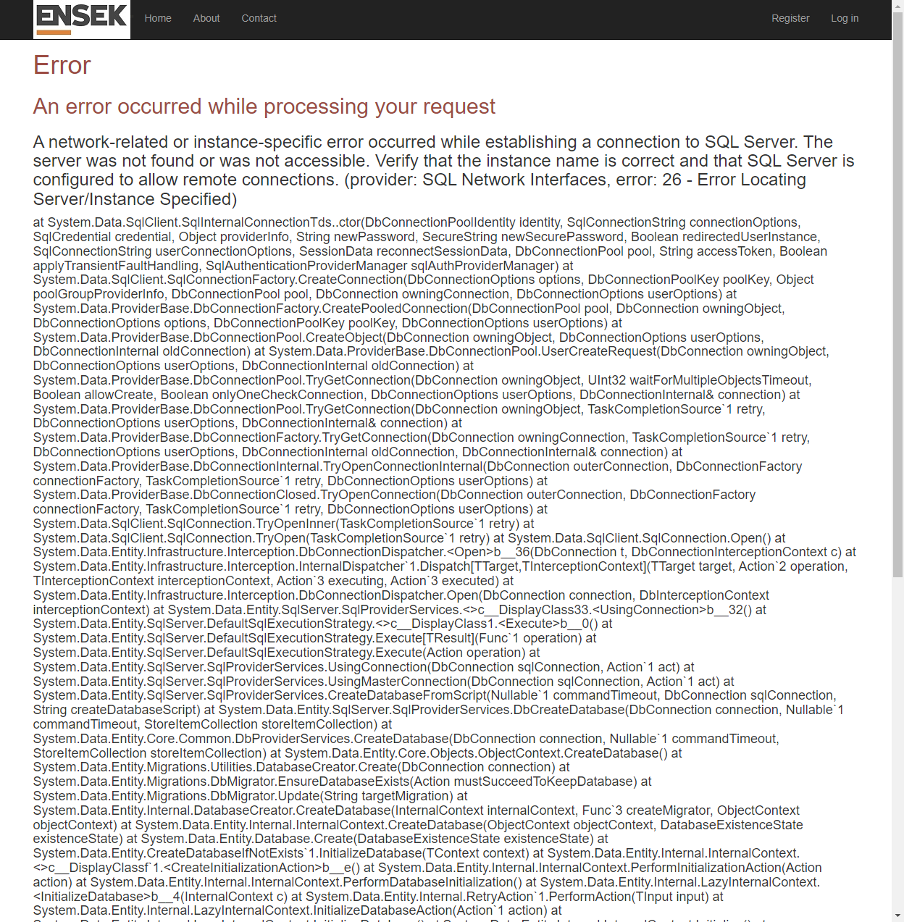

## An error occurred while processing your request

### A network-related or instance-specific error occurred while establishing a connection to SQL Server. The server was not found or was not accessible. Verify that the instance name is correct and that SQL Server is configured to allow remote connections. (provider: SQL Network Interfaces, error: 26 - Error Locating Server/Instance Specified)

#### at System.Data.SqlClient.SqlInternalConnectionTds..ctor(DbConnectionPoolIdentity identity, SqlConnectionString connectionOptions, SqlCredential credential, Object providerInfo, String newPassword, SecureString newSecurePassword, Boolean redirectedUserInstance, SqlConnectionString userConnectionOptions, SessionData reconnectSessionData, DbConnectionPool pool, String accessToken, Boolean applyTransientFaultHandling, SqlAuthenticationProviderManager sqlAuthProviderManager) at System.Data.SqlClient.SqlConnectionFactory.CreateConnection(DbConnectionOptions options, DbConnectionPoolKey poolKey, Object poolGroupProviderInfo, DbConnectionPool pool, DbConnection owningConnection, DbConnectionOptions userOptions) at System.Data.ProviderBase.DbConnectionFactory.CreatePooledConnection(DbConnectionPool pool, DbConnection owningObject, DbConnectionOptions options, DbConnectionPoolKey poolKey, DbConnectionOptions userOptions) at System.Data.ProviderBase.DbConnectionPool.CreateObject(DbConnection owningObject, DbConnectionOptions userOptions, DbConnectionInternal oldConnection) at System.Data.ProviderBase.DbConnectionPool.UserCreateRequest(DbConnection owningObject, DbConnectionOptions userOptions, DbConnectionInternal oldConnection) at System.Data.ProviderBase.DbConnectionPool.TryGetConnection(DbConnection owningObject, UInt32 waitForMultipleObjectsTimeout, Boolean allowCreate, Boolean onlyOneCheckConnection, DbConnectionOptions userOptions, DbConnectionInternal& connection) at System.Data.ProviderBase.DbConnectionPool.TryGetConnection(DbConnection owningObject, TaskCompletionSource`1 retry, DbConnectionOptions userOptions, DbConnectionInternal& connection) at System.Data.ProviderBase.DbConnectionFactory.TryGetConnection(DbConnection owningConnection, TaskCompletionSource`1 retry, DbConnectionOptions userOptions, DbConnectionInternal oldConnection, DbConnectionInternal& connection) at System.Data.ProviderBase.DbConnectionInternal.TryOpenConnectionInternal(DbConnection outerConnection, DbConnectionFactory connectionFactory, TaskCompletionSource`1 retry, DbConnectionOptions userOptions) at System.Data.ProviderBase.DbConnectionClosed.TryOpenConnection(DbConnection outerConnection, DbConnectionFactory connectionFactory, TaskCompletionSource`1 retry, DbConnectionOptions userOptions) at System.Data.SqlClient.SqlConnection.TryOpenInner(TaskCompletionSource`1 retry) at System.Data.SqlClient.SqlConnection.TryOpen(TaskCompletionSource`1 retry) at System.Data.SqlClient.SqlConnection.Open() at System.Data.Entity.Infrastructure.Interception.DbConnectionDispatcher.<Open>b__36(DbConnection t, DbConnectionInterceptionContext c) at System.Data.Entity.Infrastructure.Interception.InternalDispatcher`1.Dispatch[TTarget,TInterceptionContext](TTarget target, Action`2 operation, TInterceptionContext interceptionContext, Action`3 executing, Action`3 executed) at System.Data.Entity.Infrastructure.Interception.DbConnectionDispatcher.Open(DbConnection connection, DbInterceptionContext interceptionContext) at System.Data.Entity.SqlServer.SqlProviderServices.<>c__DisplayClass33.<UsingConnection>b__32() at System.Data.Entity.SqlServer.DefaultSqlExecutionStrategy.<>c__DisplayClass1.<Execute>b__0() at System.Data.Entity.SqlServer.DefaultSqlExecutionStrategy.Execute[TResult](Func`1 operation) at System.Data.Entity.SqlServer.DefaultSqlExecutionStrategy.Execute(Action operation) at System.Data.Entity.SqlServer.SqlProviderServices.UsingConnection(DbConnection sqlConnection, Action`1 act) at System.Data.Entity.SqlServer.SqlProviderServices.UsingMasterConnection(DbConnection sqlConnection, Action`1 act) at System.Data.Entity.SqlServer.SqlProviderServices.CreateDatabaseFromScript(Nullable`1 commandTimeout, DbConnection sqlConnection, String createDatabaseScript) at System.Data.Entity.SqlServer.SqlProviderServices.DbCreateDatabase(DbConnection connection, Nullable`1 commandTimeout, StoreItemCollection storeItemCollection) at System.Data.Entity.Core.Common.DbProviderServices.CreateDatabase(DbConnection connection, Nullable`1 commandTimeout, StoreItemCollection storeItemCollection) at System.Data.Entity.Core.Objects.ObjectContext.CreateDatabase() at System.Data.Entity.Migrations.Utilities.DatabaseCreator.Create(DbConnection connection) at System.Data.Entity.Migrations.DbMigrator.EnsureDatabaseExists(Action mustSucceedToKeepDatabase) at System.Data.Entity.Migrations.DbMigrator.Update(String targetMigration) at System.Data.Entity.Internal.DatabaseCreator.CreateDatabase(InternalContext internalContext, Func`3 createMigrator, ObjectContext objectContext) at System.Data.Entity.Internal.InternalContext.CreateDatabase(ObjectContext objectContext, DatabaseExistenceState existenceState) at System.Data.Entity.Database.Create(DatabaseExistenceState existenceState) at System.Data.Entity.CreateDatabaseIfNotExists`1.InitializeDatabase(TContext context) at System.Data.Entity.Internal.InternalContext.<>c__DisplayClassf`1.<CreateInitializationAction>b__e() at System.Data.Entity.Internal.InternalContext.PerformInitializationAction(Action action) at System.Data.Entity.Internal.InternalContext.PerformDatabaseInitialization() at System.Data.Entity.Internal.LazyInternalContext.<InitializeDatabase>b__4(InternalContext c) at System.Data.Entity.Internal.RetryAction`1.PerformAction(TInput input) at System.Data.Entity.Internal.LazyInternalContext.InitializeDatabaseAction(Action`1 action) at System.Data.Entity.Internal.LazyInternalContext.InitializeDatabase() at System.Data.Entity.Internal.InternalContext.Initialize() at System.Data.Entity.Internal.InternalContext.GetEntitySetAndBaseTypeForType(Type entityType) at System.Data.Entity.Internal.Linq.InternalSet`1.Initialize() at System.Data.Entity.Internal.Linq.InternalSet`1.get_InternalContext() at System.Data.Entity.Infrastructure.DbQuery`1.System.Linq.IQueryable.get_Provider() at System.Data.Entity.QueryableExtensions.FirstOrDefaultAsync[TSource](IQueryable`1 source, Expression`1 predicate, CancellationToken cancellationToken) at System.Data.Entity.QueryableExtensions.FirstOrDefaultAsync[TSource](IQueryable`1 source, Expression`1 predicate) at Microsoft.AspNet.Identity.EntityFramework.UserStore`6.<GetUserAggregateAsync>d__67.MoveNext() --- End of stack trace from previous location where exception was thrown --- at System.Runtime.CompilerServices.TaskAwaiter.ThrowForNonSuccess(Task task) at System.Runtime.CompilerServices.TaskAwaiter.HandleNonSuccessAndDebuggerNotification(Task task) at Microsoft.AspNet.Identity.TaskExtensions.CultureAwaiter`1.GetResult() at Microsoft.AspNet.Identity.Owin.SignInManager`2.<PasswordSignInAsync>d__25.MoveNext() --- End of stack trace from previous location where exception was thrown --- at System.Runtime.CompilerServices.TaskAwaiter.ThrowForNonSuccess(Task task) at System.Runtime.CompilerServices.TaskAwaiter.HandleNonSuccessAndDebuggerNotification(Task task) at EnsekAutomationTest.UI.MVC.Controllers.AccountController.<Login>d__11.MoveNext() in C:\GIT\configurationTest\Test Application\EnsekAutomationTest.UI.MVC\Controllers\AccountController.cs:line 78 --- End of stack trace from previous location where exception was thrown --- at System.Runtime.CompilerServices.TaskAwaiter.ThrowForNonSuccess(Task task) at System.Runtime.CompilerServices.TaskAwaiter.HandleNonSuccessAndDebuggerNotification(Task task) at System.Web.Mvc.Async.TaskAsyncActionDescriptor.EndExecute(IAsyncResult asyncResult) at System.Web.Mvc.Async.AsyncControllerActionInvoker.<>c__DisplayClass8_0.<BeginInvokeAsynchronousActionMethod>b__1(IAsyncResult asyncResult) at System.Web.Mvc.Async.AsyncResultWrapper.WrappedAsyncResult`1.CallEndDelegate(IAsyncResult asyncResult) at System.Web.Mvc.Async.AsyncResultWrapper.WrappedAsyncResultBase`1.End() at System.Web.Mvc.Async.AsyncControllerActionInvoker.EndInvokeActionMethod(IAsyncResult asyncResult) at System.Web.Mvc.Async.AsyncControllerActionInvoker.AsyncInvocationWithFilters.<>c__DisplayClass11_0.<InvokeActionMethodFilterAsynchronouslyRecursive>b__0() at System.Web.Mvc.Async.AsyncControllerActionInvoker.AsyncInvocationWithFilters.<>c__DisplayClass11_2.<InvokeActionMethodFilterAsynchronouslyRecursive>b__2() at System.Web.Mvc.Async.AsyncControllerActionInvoker.<>c__DisplayClass7_0.<BeginInvokeActionMethodWithFilters>b__1(IAsyncResult asyncResult) at System.Web.Mvc.Async.AsyncResultWrapper.WrappedAsyncResult`1.CallEndDelegate(IAsyncResult asyncResult) at System.Web.Mvc.Async.AsyncResultWrapper.WrappedAsyncResultBase`1.End() at System.Web.Mvc.Async.AsyncControllerActionInvoker.EndInvokeActionMethodWithFilters(IAsyncResult asyncResult) at System.Web.Mvc.Async.AsyncControllerActionInvoker.<>c__DisplayClass3_6.<BeginInvokeAction>b__4() at System.Web.Mvc.Async.AsyncControllerActionInvoker.<>c__DisplayClass3_1.<BeginInvokeAction>b__1(IAsyncResult asyncResult)